Name : LOKESH J Course : Software Engineering
Reg No : 192311216
Experiment – 1

Question : Create a Kanban Board to Visualize the Tasks.
• Create Columns for To Do, In-Progress and Done.
• Add Atleast 5 Sample Tasks
• Move the Tasks across the Columns to Simulate the Workflow.

Link : https://saveetha-team-tcs.atlassian.net/jira/software/c/projects/KS/boards/2

1 . Login into your Jira Account and click the plus in the space in the side bar .
2 . Now choose the Kanban from the Space Templates .
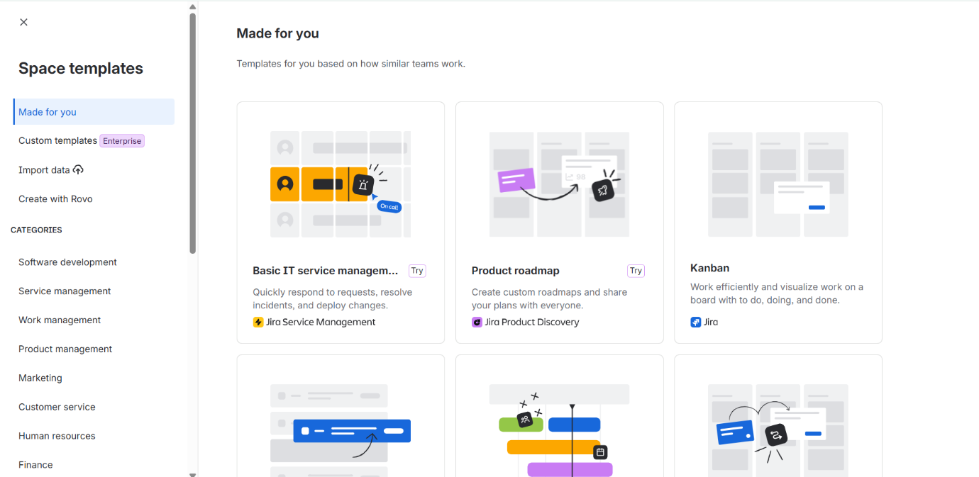

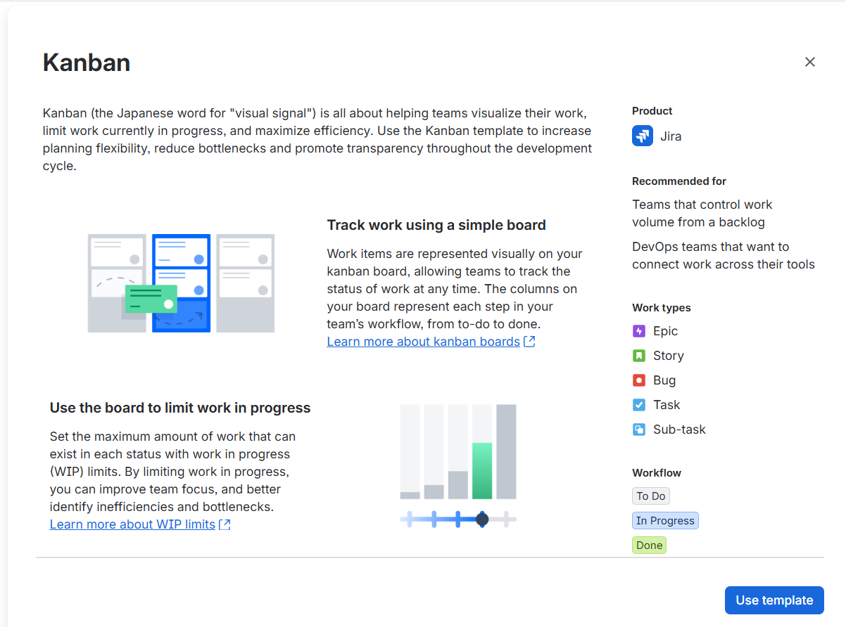
3. Click on use template.

4 . Now Fill the Details for creating the kanban Board .
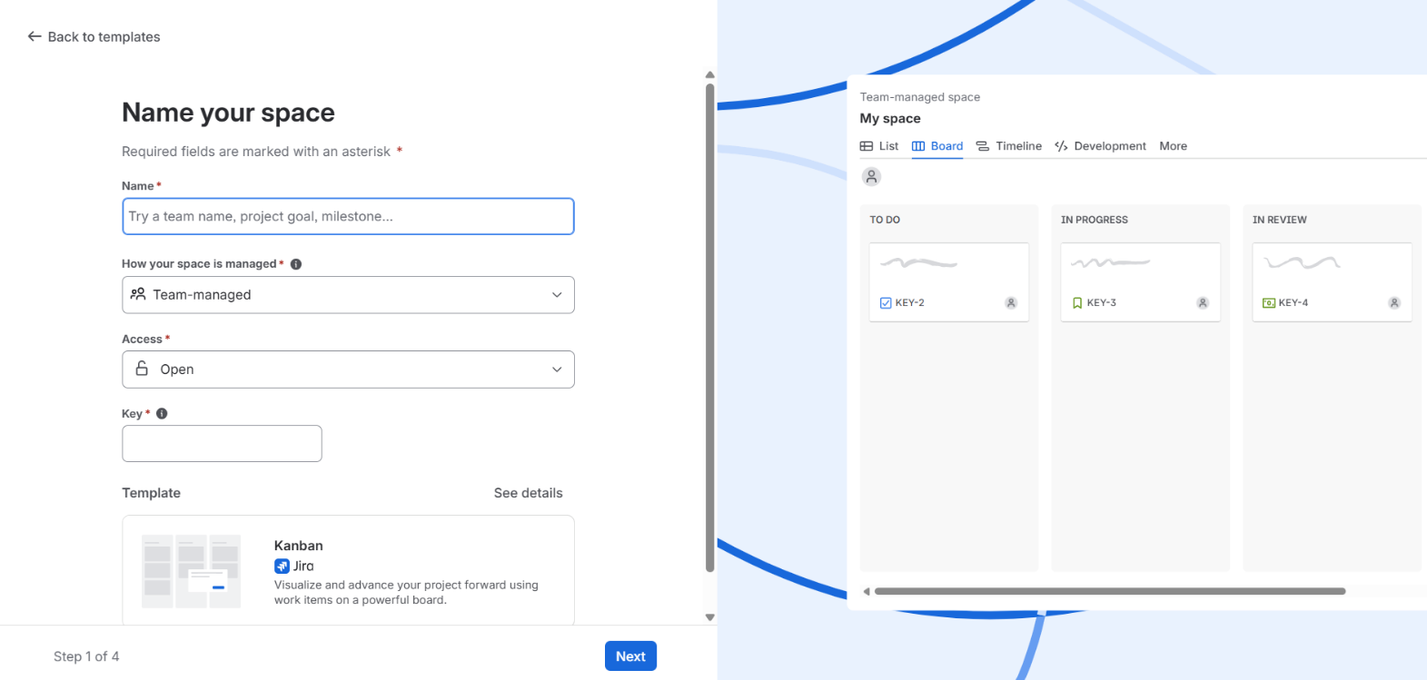

5. After Creating the Kanban , You will see the To-Do , In Progress , In Review , Done section .
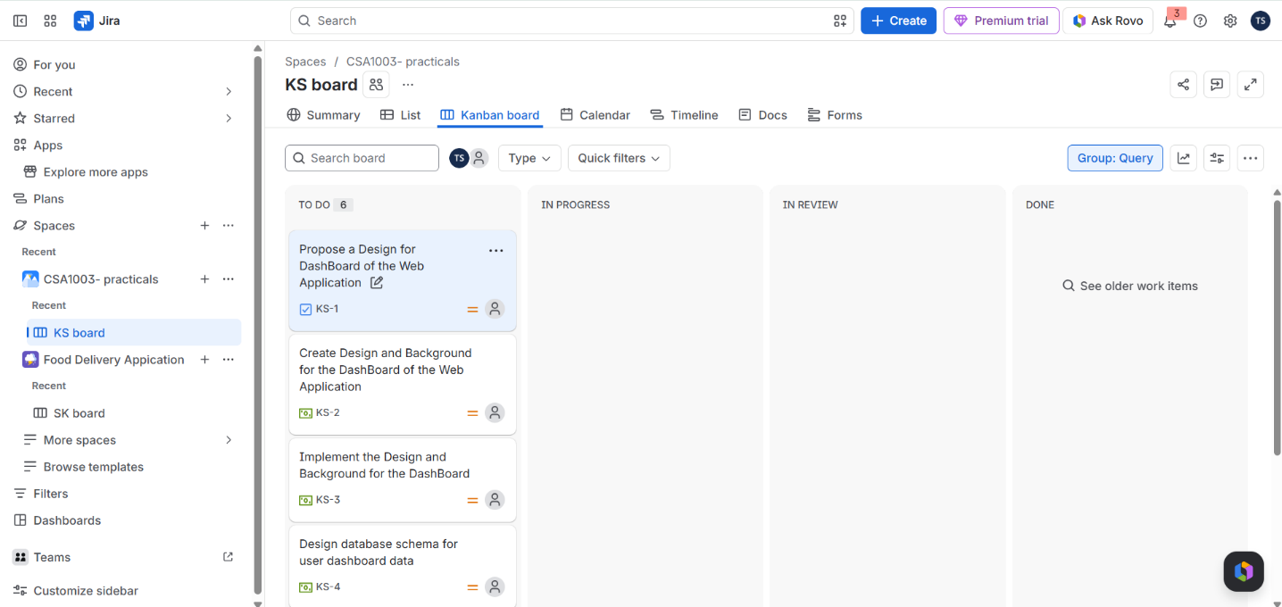

6. Now you can Create Tasks in the To Do list and move Across the various sections like In Progress , In Review and Done section.

